# Sharepoint 2013 How to customize context menu view in document library

# [Hide CallOuts in a SharePoint 2013 Custom List](http://www.learningsharepoint.com/2013/05/18/hide-callouts-in-a-sharepoint-2013-task-list/)

The instructions here work… i.e. just use the “Newsletter, no lines” View Stle in the list view.

Other options might be to create a Custom Field in the content type. Might be good if we start storing the PDF in the forms document library.

Today I am Posting a quick tip about How to Hide CallOuts in a SharePoint 2013 Task List.  
CallOuts by default, are displayed on “Task Name” field in a typical SharePoint 2013 Tasks List.See the screen below.

[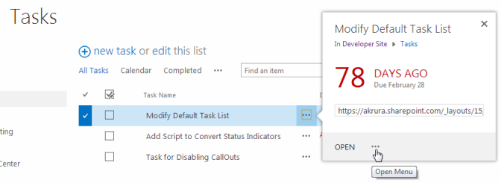](http://www.learningsharepoint.com/wp-content/uploads/2013/05/defaultTasklist.png)

To disable or hide these CallOuts **Permanently**, you would need to modify the **CalloutMenu & CalloutMenuAllowed** Properties of this Column or use a Custom Column with CalloutMenuAllowed set to disabled.Read more about this at [Here](http://www.learningsharepoint.com/2013/05/13/disable-callout-popup-for-a-field-or-column-in-sharepoint-2013-list/).

For a quick and dirty fix to remove CallOuts from a “Task Name” Field and display the regular ECB (Edit Control Block) menu you can simply Create a Custom View with a different style (other than default). Lets look at the Steps –

1. Navigate to your ListView WebPart or Task List.  
2. Select the List Tab and select “Create View”  
[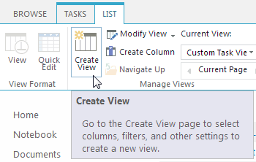](http://www.learningsharepoint.com/wp-content/uploads/2013/05/Createview.png)

3. Next in the Create New View Page add a name for your view and scroll down to the “Style”section. Select “Newsletter, no lines” in View Style: and save the View.(See below)

[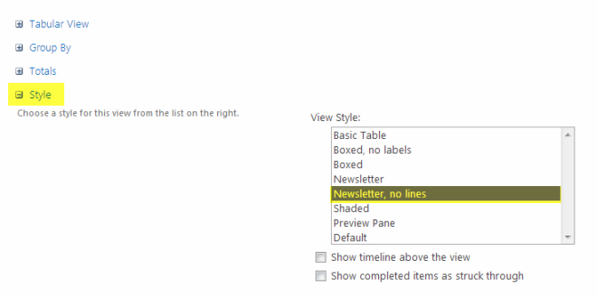](http://www.learningsharepoint.com/wp-content/uploads/2013/05/View-Style.png)

With the new View the List View looks like below –

[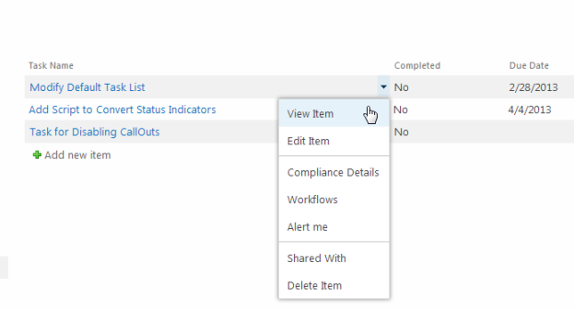](http://www.learningsharepoint.com/wp-content/uploads/2013/05/TaskListwithECB.png)

Enjoy the new View.

# [SharePoint 2013 CallOut Popup Tutorial](http://www.learningsharepoint.com/2013/05/09/sharepoint-2013-callout-popup-tutorial/)

Useful tutorial. Includes how to hide callout entries.

# [Disable CallOut Popup for a Field or Column in SharePoint 2013 List](http://www.learningsharepoint.com/2013/05/13/disable-callout-popup-for-a-field-or-column-in-sharepoint-2013-list/)

http://sharepoint.stackexchange.com/questions/140378/sharepoint-2013-how-to-customize-context-menu-view-in-document-library

|  |  |  |
| --- | --- | --- |
| I want to customize the view of context menu in a document library.  So first image is what looks and second image is what i want, like context menu in lists. I mean i dont want the big box.  enter image description here  enter image description here  [document-library](http://sharepoint.stackexchange.com/questions/tagged/document-library)   |  |  | | --- | --- | | [share](http://sharepoint.stackexchange.com/q/140378)[improve this question](http://sharepoint.stackexchange.com/posts/140378/edit) | asked May 1 '15 at 15:48  [[https://www.gravatar.com/avatar/8f7e51357a715ee9bb8c5681717b9cac?s=32&d=identicon&r=PG](http://sharepoint.stackexchange.com/users/34804/erkan)](http://sharepoint.stackexchange.com/users/34804/erkan)  [Erkan](http://sharepoint.stackexchange.com/users/34804/erkan)  **10**4 | |
|  | add a comment |

## 1 Answer

[active](http://sharepoint.stackexchange.com/questions/140378/sharepoint-2013-how-to-customize-context-menu-view-in-document-library?answertab=active#tab-top)[oldest](http://sharepoint.stackexchange.com/questions/140378/sharepoint-2013-how-to-customize-context-menu-view-in-document-library?answertab=oldest#tab-top)[**votes**](http://sharepoint.stackexchange.com/questions/140378/sharepoint-2013-how-to-customize-context-menu-view-in-document-library?answertab=votes#tab-top)

|  |  |
| --- | --- |
| up vote1down voteaccepted | You can try this, or the equivalent in Powershell:  SPList list = site.RootWeb.Lists["YourListName"];  SPField field = list.Fields["Name"];  field.CalloutMenu = false;  field.CalloutMenuAllowed = SPField.ListItemMenuState.Prohibited;  field.ListItemMenu = true;  field.ListItemMenuAllowed = SPField.ListItemMenuState.Required;  field.Update();  list.Update(); |